UID: 2505070 Date: 23/08/2025
Subject_name: ART OF PROGRAMMING

MINI PROJECT REPORT

STUDENT GRADING SYSTEM IN C

DESCRIPTION:
The Student Grading System is a mini project developed using the C programming language. It allows users to input student details and their marks in various subjects. It takes number of students, their marks in three subjects (Art of Programming , Applied Mathematics,Computer Networks) as the input and the system calculates the total marks, average, and grade of each student.

LIST OF MODULES:
- Student Data Entry Module - To input student name, roll number, and marks.
- Grade Calculation Module - To compute total marks, average, and assign grade.
- Result Display Module - To show student details along with the grade.

TECHNOLOGIES USED:
- Programming Language: C (GCC Compiler v13.2.0)
- Visual Studio Code
- IDE Used: Code::Blocks 20.03 / VS Code 1.90.0
- Operating System: Windows 11

PLAGIARISM REPORT:
Plagiarism Percentage: 16%
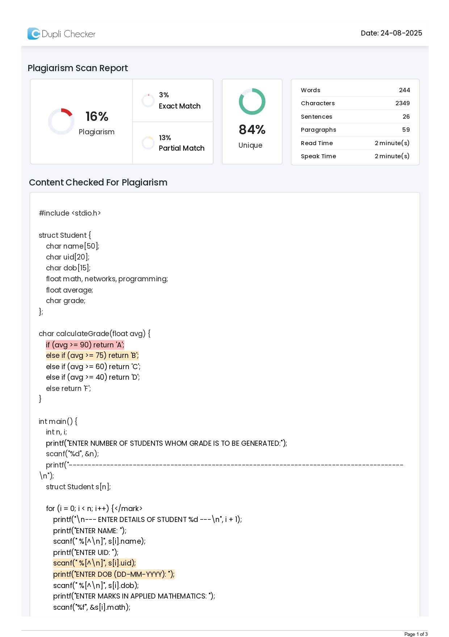
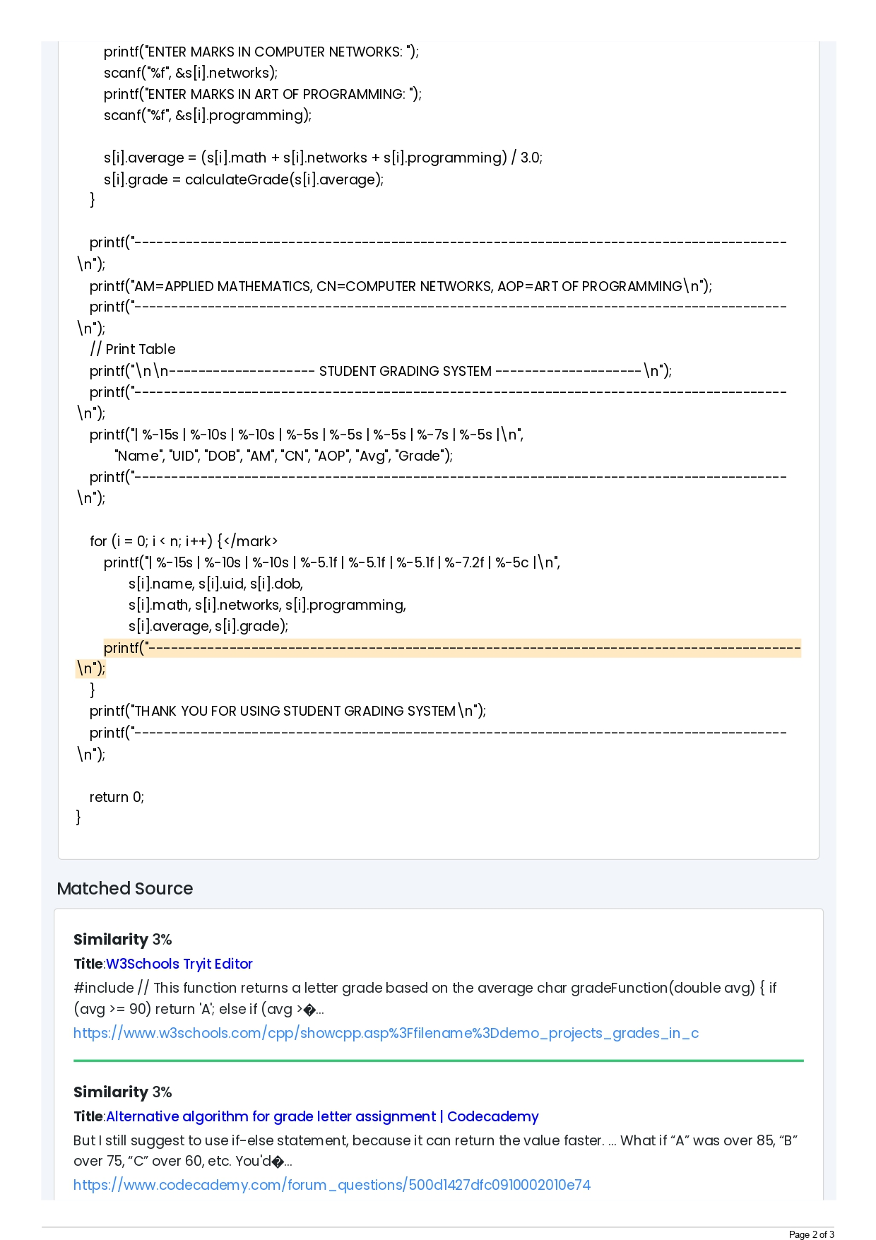

CODE:
#include <stdio.h>

struct Student {
char name[50];
char uid[20];
char dob[15];
float math, networks, programming;
float average;
char grade;
};

char calculateGrade(float avg) {
if (avg >= 90) return 'A';
else if (avg >= 75) return 'B';
else if (avg >= 60) return 'C';
else if (avg >= 40) return 'D';
else return 'F';
}

int main() {
int n, i;
printf("ENTER NUMBER OF STUDENTS WHOM GRADE IS TO BE GENERATED:");
scanf("%d", &n);
printf("-----------------------------------------------------------------------------------------\n");
struct Student s[n];

for (i = 0; i < n; i++) {
printf("\n--- ENTER DETAILS OF STUDENT %d ---\n", i + 1);
printf("ENTER NAME: ");
scanf(" %[^\n]", s[i].name);
printf("ENTER UID: ");
scanf(" %[^\n]", s[i].uid);
printf("ENTER DOB (DD-MM-YYYY): ");
scanf(" %[^\n]", s[i].dob);
printf("ENTER MARKS IN APPLIED MATHEMATICS: ");
scanf("%f", &s[i].math);
printf("ENTER MARKS IN COMPUTER NETWORKS: ");
scanf("%f", &s[i].networks);
printf("ENTER MARKS IN ART OF PROGRAMMING: ");
scanf("%f", &s[i].programming);

s[i].average = (s[i].math + s[i].networks + s[i].programming) / 3.0;
s[i].grade = calculateGrade(s[i].average);
}

printf("-----------------------------------------------------------------------------------------\n");
printf("AM=APPLIED MATHEMATICS, CN=COMPUTER NETWORKS, AOP=ART OF PROGRAMMING\n");
printf("-----------------------------------------------------------------------------------------\n");
// Print Table
printf("\n\n-------------------- STUDENT GRADING SYSTEM --------------------\n");
printf("-----------------------------------------------------------------------------------------\n");
printf("| %-15s | %-10s | %-10s | %-5s | %-5s | %-5s | %-7s | %-5s |\n",
"Name", "UID", "DOB", "AM", "CN", "AOP", "Avg", "Grade");
printf("-----------------------------------------------------------------------------------------\n");

for (i = 0; i < n; i++) {
printf("| %-15s | %-10s | %-10s | %-5.1f | %-5.1f | %-5.1f | %-7.2f | %-5c |\n",
s[i].name, s[i].uid, s[i].dob,
s[i].math, s[i].networks, s[i].programming,
s[i].average, s[i].grade);
printf("-----------------------------------------------------------------------------------------\n");
}
printf("THANK YOU FOR USING STUDENT GRADING SYSTEM\n");
printf("-----------------------------------------------------------------------------------------\n");

return 0;
}

OUTPUT: 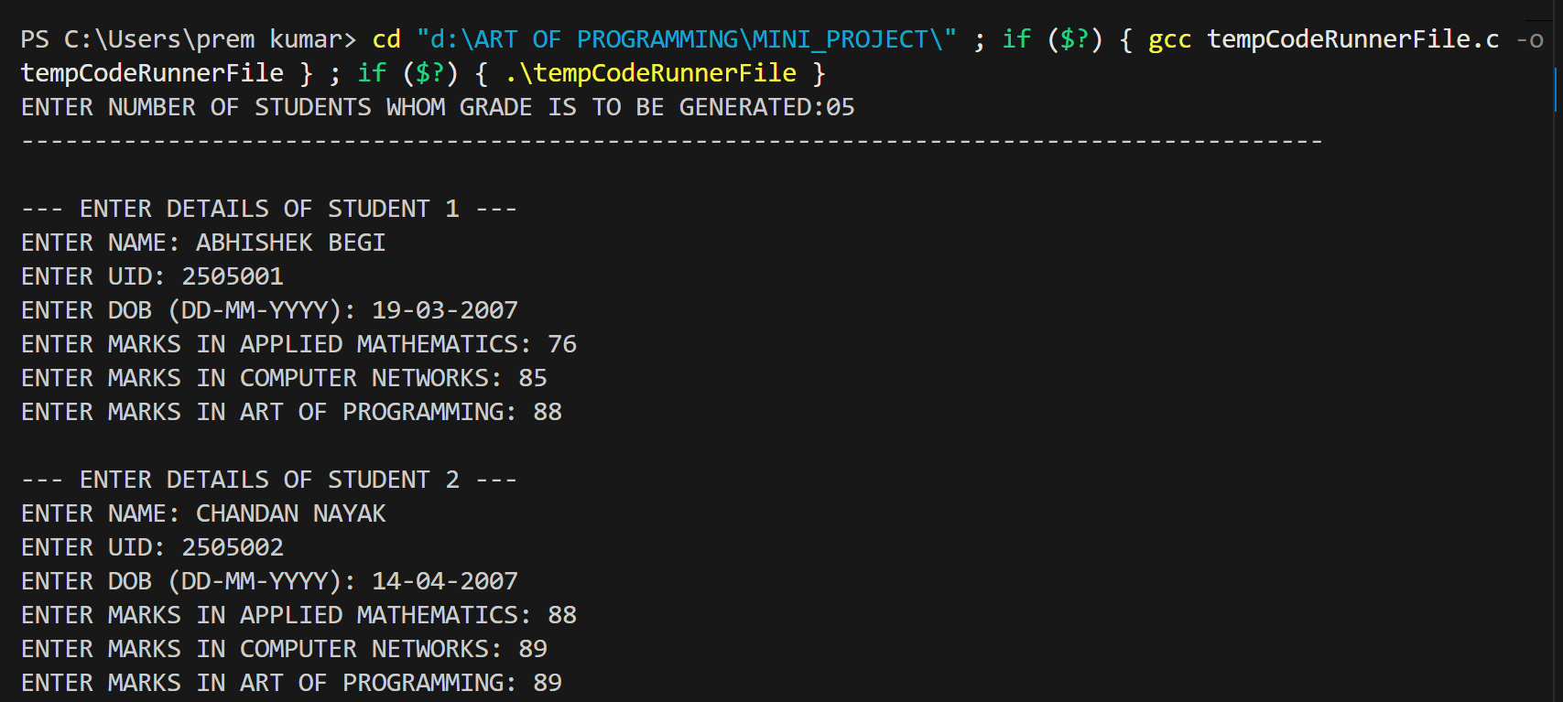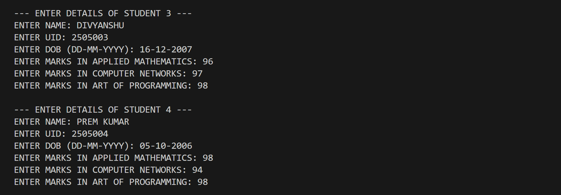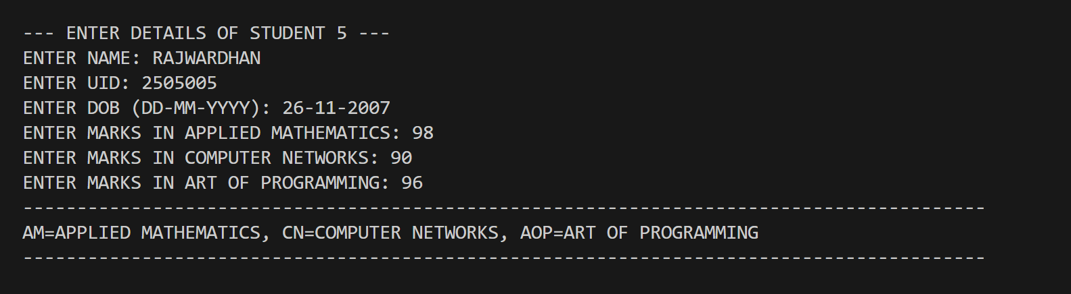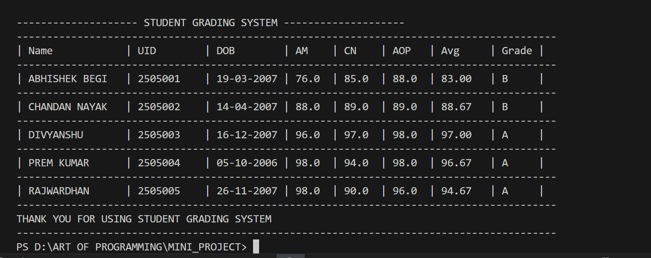
CONCLUSION:
- This system simplifies the process of evaluating student performance and helps in maintaining academic records efficiently. It provides an easy-to-use console-based interface for entering and displaying results.

- This project helped me understand the concepts of structures, arrays, loops, and conditional statements in C programming. The main challenge was handling multiple student inputs and displaying results in a neat table format. I solved this by using arrays of structures and formatted printing (printf with width specifiers).

- Through this project, I learned how to design modular code, improve problem-solving skills, and present outputs clearly.

